# [MS-E2112 - Multivariate statistical analysis](https://mycourses.aalto.fi/course/view.php?id=7621) – Home exercise 4

Srikanth Gadicherla, 546195 February 5, 2016

Problem 1a

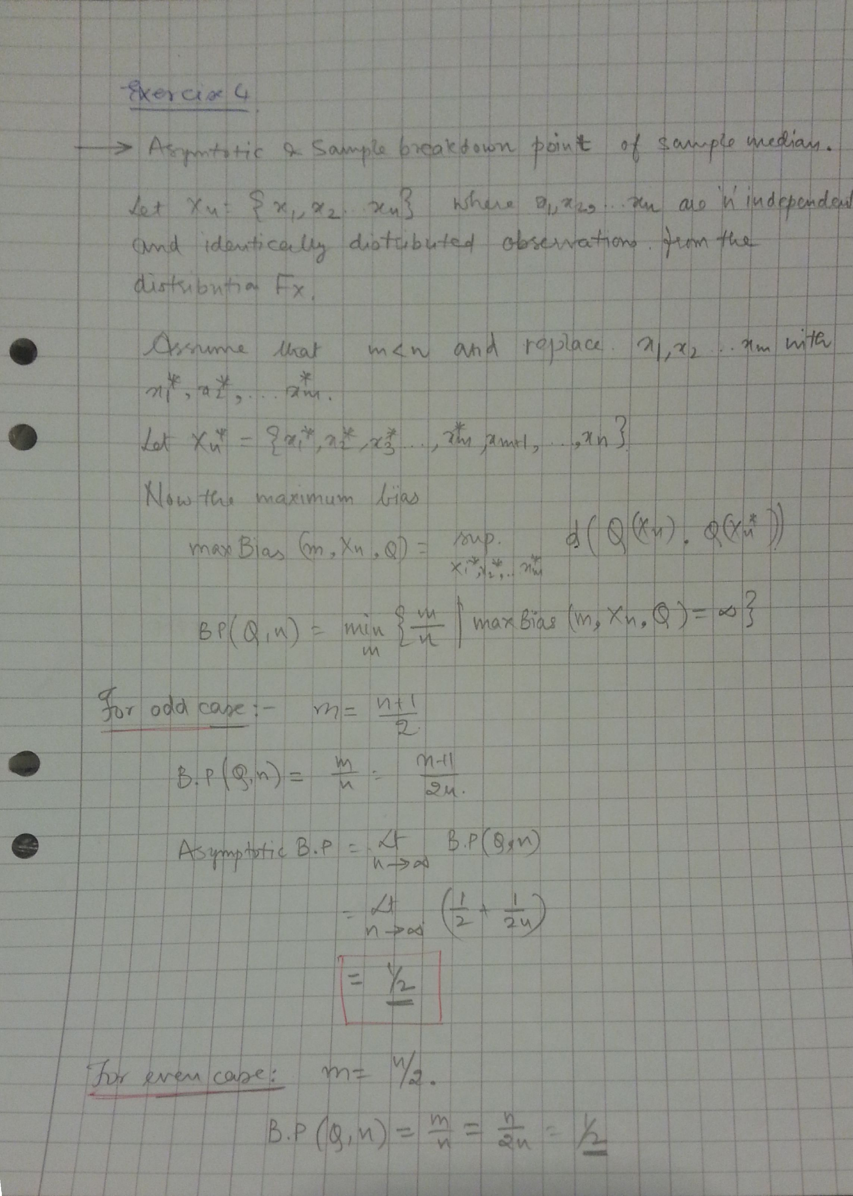

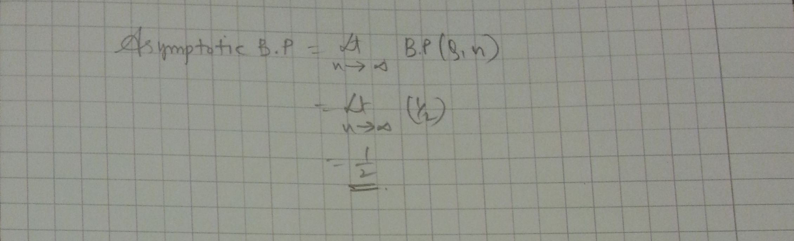

Problem1b

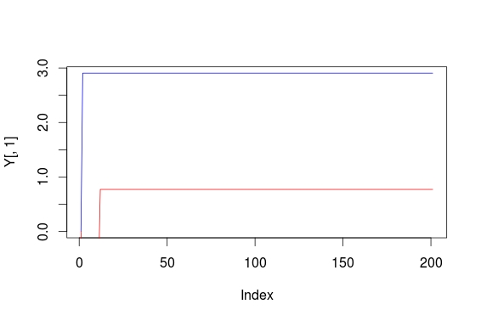

The empirical influence function for the median is given in the above figure for bivariate data.

Problem1c

As, the empirical influence for the median is clearly bounded (here the negaitive part of the plot is not available) it tells that median is a robust estimate.